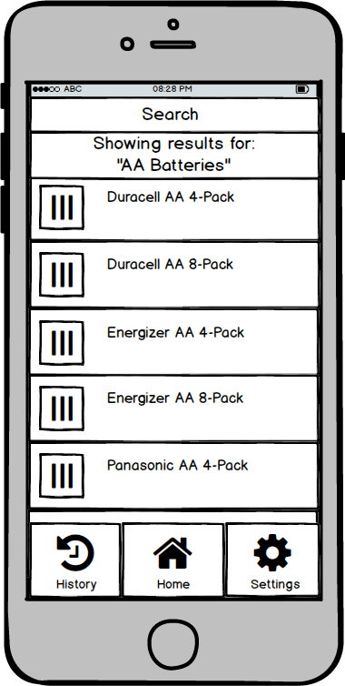

O 828 PM

**Search**

**Showing results for: "AA Botteries"**

**Durocell AA 4-Pack**

Durocell AA 8-Pack

Energizer AA 4-Pack

Energizer AA 8-Pack

**Ponosonic AA 4-Pack**

**JD || Â | 0 History HOme Settings**